**Đặng Hoàng Nguyên – SE171946**

**Phạm Trung Hậu – SE171764**

**Were the pings successful? Explain.**

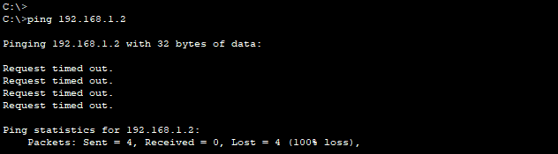No, because we did not configure the switch yet.

**Were the pings successful?**

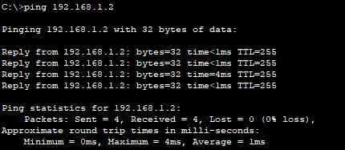 Yes

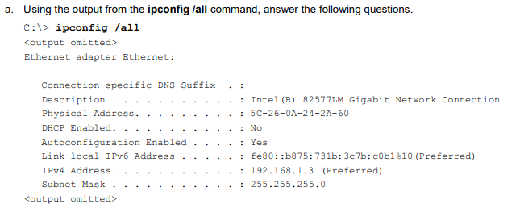

**What is the OUI portion of the MAC address for this device?** 5C-26-0A

**What is the serial number portion of the MAC address for this device?** 24-2A-60

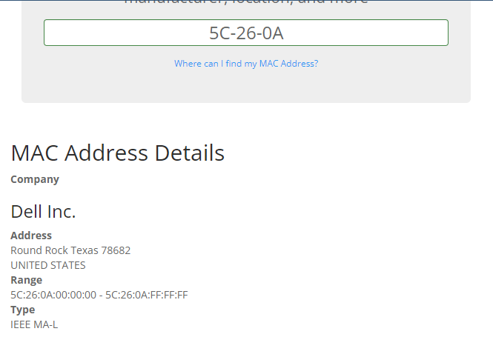**Using the example above, find the name of the vendor that manufactured this NIC**? Dell Inc.

**Identify the serial number portion of the MAC address for the NIC of PC-A.** D9.B0.E3

**Identify the name of the vendor that manufactured the NIC of PC-A.** Cicso System, INC.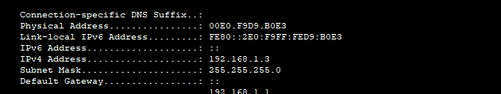

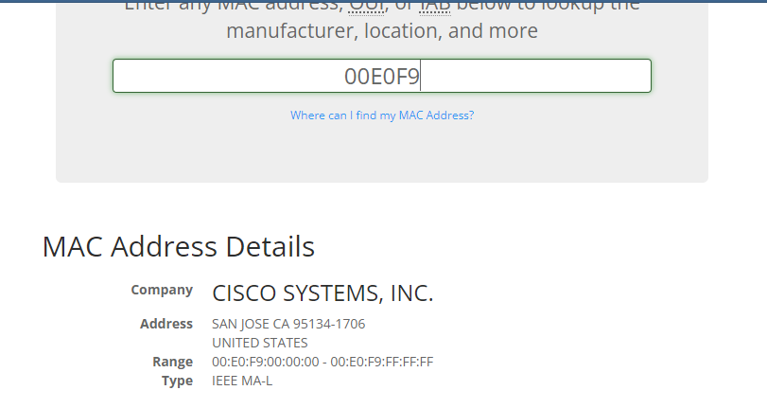

**What is the MAC address for VLAN 1 on S1?** 00-02-4a-9b-b9-44

**What is the MAC serial number for VLAN 1?** 9b-b9-44

**What is the OUI for VLAN 1?** 00-02-4a

**Based on this OUI, what is the name of the vendor?** Cisco Systems,inc.

**What does bia stand for?** Burned in address.

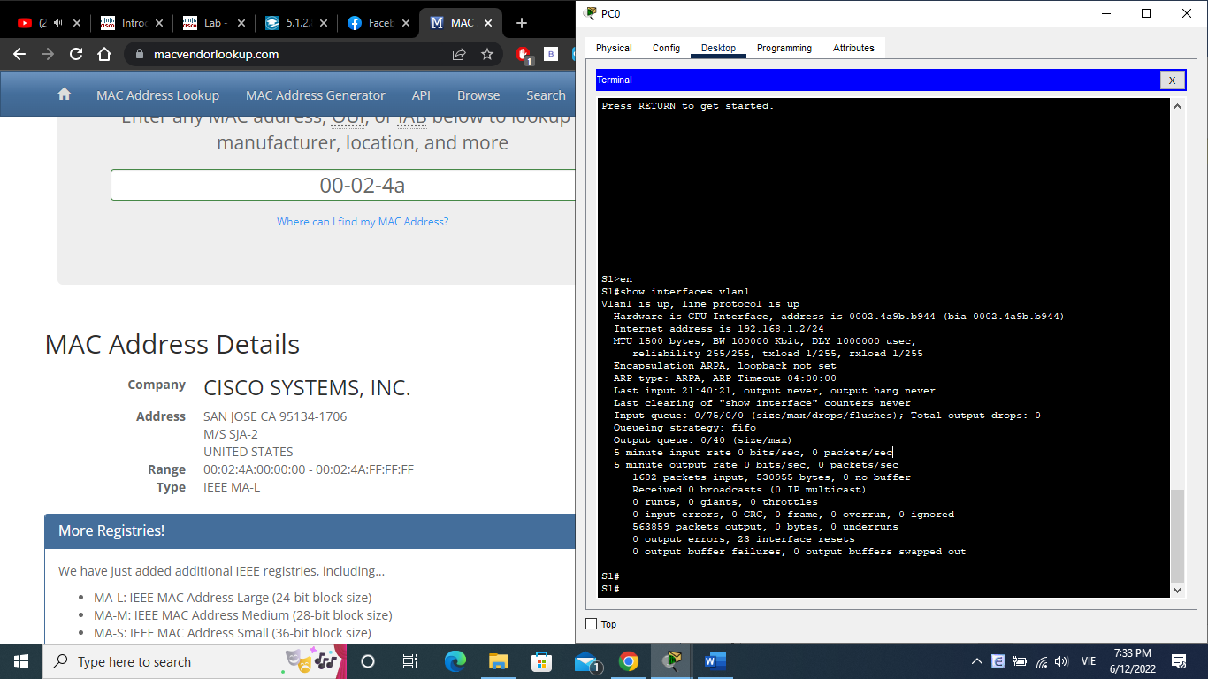**Why does the output show the same MAC address twice?**

Because the mac can be changed through command, the bia is the fixed address they are in “( )”

**What Layer 2 addresses are displayed on S1?** S1 VLAN 1 ip address, PC ip address

**What Layer 3 addresses are displayed on S1?** S1 Vlan1 mac address, PC ip address



**Can you have broadcasts at the Layer 2 level? If so, what would the MAC address be?**

Yes we can, it can be defined by arp and it would be FF-FF-FF-FF-FF-FF

**Why would you need to know the MAC address of a device?**

Because when we know MAC address, we can easily know information about that device as well as about the security. You can spoof if you know MAC address